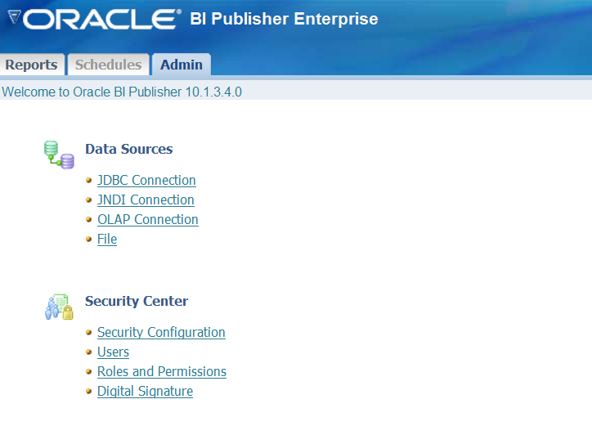

Select allow guest and enter EXOR REPORTS (uppercase). Hit the apply button. Restart the service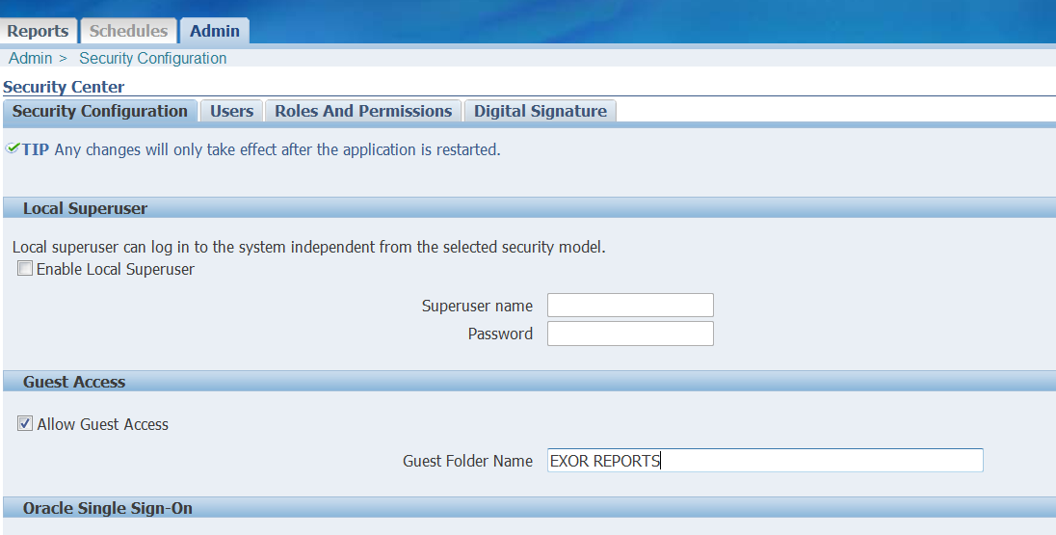

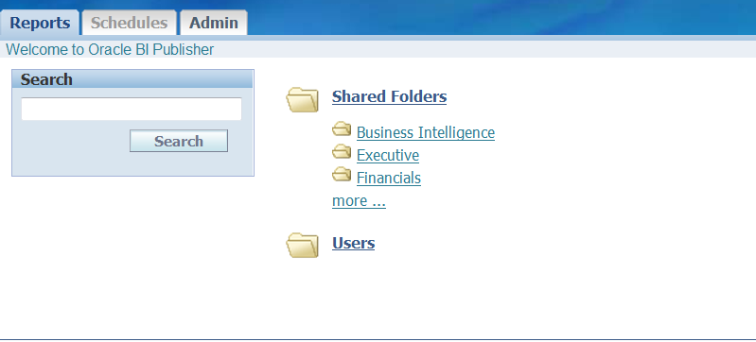

Select shared folders

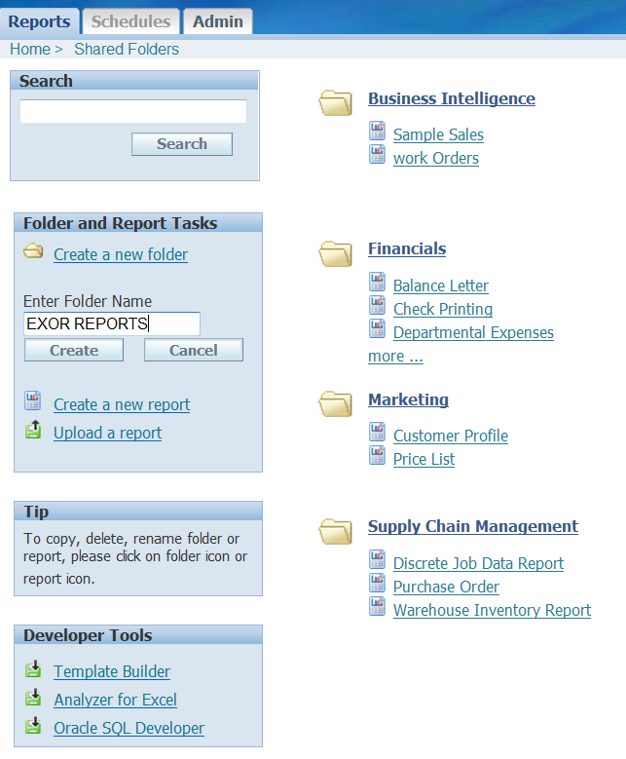

Create new folder EXOR REPORTS (uppercase)

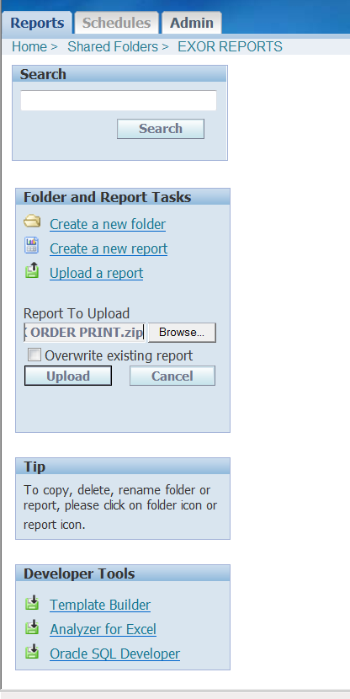

Upload the report navigate the zip file and press upload

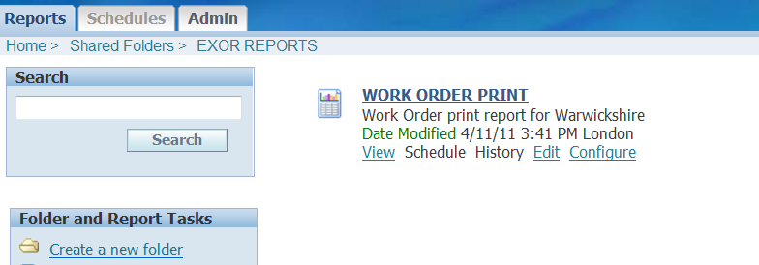

Select edit check that the default data source is set to the data source created earlier

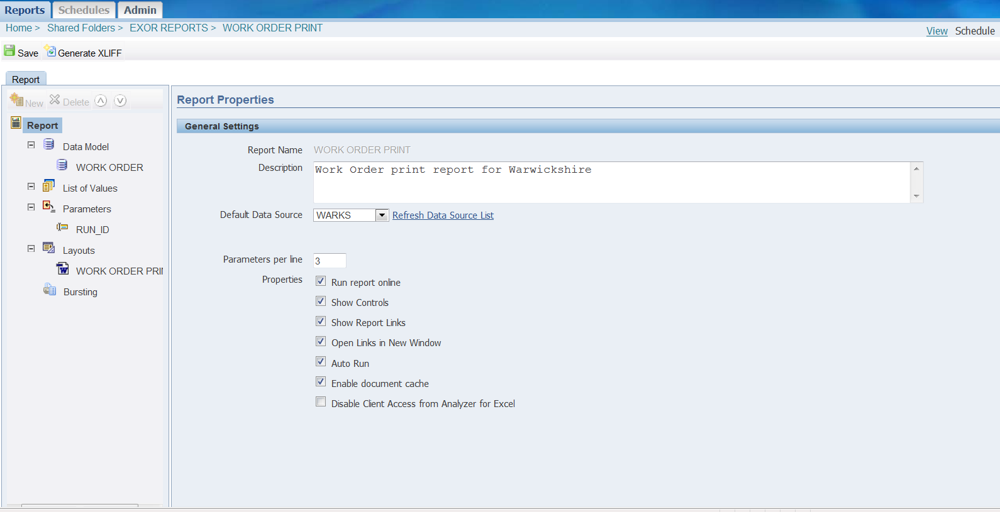

Metadata

Report name (uppercase)

Server url

Report folder (uppercase)

Param (uppercase)

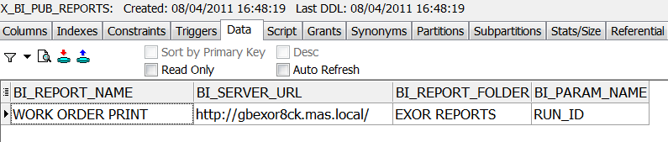

insert into x_bi_pub_reports

values

( 'WORK ORDER PRINT',

'http://gbexor8ck.mas.local/',

'EXOR REPORTS',

'RUN_ID')

/

Open a command line session

Cd D:\work_order_report\install

Log into sqlplus as highways owner

Run

@ddl_script

Cd D:\work_order_report\Admin\views

Log into sqlplus as highways owner

Run

@work_order_report_header.vw

@work_order_report_null_defect.vw

@ work_order_report_with_defect.vw

@work_order_report.vw

Cd D:\work_order_report\Admin\pck

Log into sqlplus as highways owner

Run

@ X_BI_PUB_REPORT_UTL.pkh

@X_BI_PUB_REPORT_UTL.pkb